|  | **Department of Computer Science**  **University of Management and Technology** |
| --- | --- |

**Assignment Description File**

| Course Name: | **Software Engineering** |
| --- | --- |
| Section: | **V10** |
| Teacher: | **Fasiha Ashraf** |
| Student Name n ID | **F2021266447 Maha**  **F2021266433 Hadea Batool**  **F2021266411 Ayesha Yousaf**  **F2021266256 Rubiya** |
| Assignment No.: | **3** |
| Deadline: | FOLLOW LMS SUBMISSION DEADLINE |

**NOTE: PLAGIARIZED ASSIGNMENT EITHER FROM CLASSMATES OR INTERNET WILL BE MARKED STRAIGHT ZERO.NO ASSIGNMENT WILL BE ACCEPTED AFTER DEADLINE.ALWAYS MENTION SECTION ON ASSIGNMENT**

**FOLLOW THE TEMPLATE ATTACHED**

**Assignment Description:**

**Q1:** Feature comparison of Existing Systems

**Q2:** Draw DFDs

**Submission Guidelines:**

Make a word file.

Submit hard copy in class

**SEE THE TEMPLATE ATTACHED**

# Feature Comparison

Give a feature comparison of existing systems in the form of a Table

**Table 1 with 4 Existing Systems:**

| **Sr No** | **Comparison Feature** | **Shealth writer** | **AI to Human text converter** | **AI text converter** | **AI converter tool** |
| --- | --- | --- | --- | --- | --- |
| 1 | **Output Accuracy** | When it comes to detection accuracy, [Stealthwriter](https://stealthwriter.ai/detector) boasts an impressive accuracy rate of over 99%, consistently outperforming its peers. It is a top choice for content verification. | The tool converts text accurately as it has versions like simple, normal, and advanced text for SEO and many more. | Its accuracy at identifying AI-generated texts is 98 to 100%. | Expеriеncе fast and reliable convеrsion of your AI tеxt. |
| 2 | **Interface** | User-friendly easy to use | AI to-human text converter boasts a simple, user-friendly, and easy-to-use interface. | AI Text Converter Tool interface is user-friendly and easy to use. | Simple and User-friendly interface |
| 3 | **Speed** | Fast | Extremely fast | Very fast | Very fast |
| 4 | **Platform** | Website | Website | Website | Website |
| 5 | **Multi-**  **language**  **Support** | Shealth writers have the ability to handle a wide range of languages | AI to human text converter supports multi-language | Supports multi-languages. | Support multiple languages |
| 6 | **Scalability** | Scalable easy to customized | Scalable | Highly Scalable | Not scalable |
| 7 | **Cost** | It offers a 7-day free trial and unlimited uses for a reasonable price | Free of cost | Free of cost. You can rest assured that you won't need to pay for the service. It is entirely free of cost. There are no hidden fees at all. | This tool offers a complеtеly frее sеrvicе, |
| 8 | **Number of words** | There is no limit. | No limitation | No limitation | No limit |
| 9 | **Security** | Highly secured | Secured | Safe and 100% secured | Safe and secure provides 100% secure access and safeguarding your data and privacy. |

**Table 2: 3 Existing Applications + Our Project**

| **Sr No.** | **Comparison Feature** | **AI to Human Converter** | **AI to Human** | **Undetectable AI** | **AIWrite** |
| --- | --- | --- | --- | --- | --- |
| 1 | **Output Accuracy** | The tool removes the AI signature watermark from the text and keeps the generated text as it is without changing it. | The tool converts text accurately as it has versions like simple, normal, and advanced text, for SEO and many more. | The tool converts text accurately and allows users to create different drafts. | N/A |
| 2 | **Interface** | User-friendly | A bit difficult | User-friendly | User-friendly |
| 3 | **Speed** | Fast | Slows with the increase of content. | Average | N/A |
| 4 | **Platform** | Website | Website | Website | Website |
| 5 | **Multi-language**  **Support** | Supports | Supports | Supports | Doesn’t support, Only English |
| 6 | **Scalability** | Scalable | Not Scalable | Scalable | N/A |
| 7 | **Cost** | Free of cost | Free of cost | Costly | Free of cost |
| 8 | **Number of words** | There is no limit. | No limit | Price increases with the increase in the word limit. | N/A |
| 9 | **Security** | N/A | Secure | Secure | Secure |

# Data flow diagram (optional)

## Data Flow Diagram Level 0

*Identifies sources and sinks only e.g*

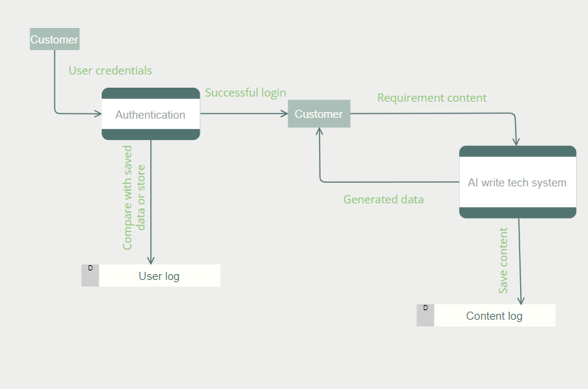

## Data Flow Diagram Level 1

*Identifies actual data flows and data stores e.g*

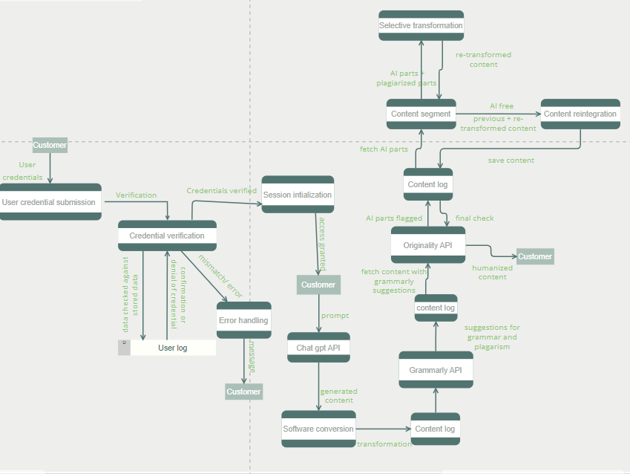

## Data Flow Diagram Level 2

If Applicable to your scenario